Nepal College of Information Technology
Unit Test
Fall 2010
Program: BE Time: 2 hrs
Semester: Fall (I) FM: 70
Subject: Basic Electrical Engineering PM: 35
Attempt All questions.
1 a) Using Nodal analysis, find the current in the 5Ω resistor in the figure below: [7]
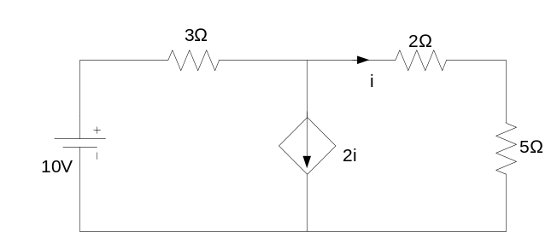

b) Using Superposition theorem, calculate the current flowing through 4Ω resistor. [8]
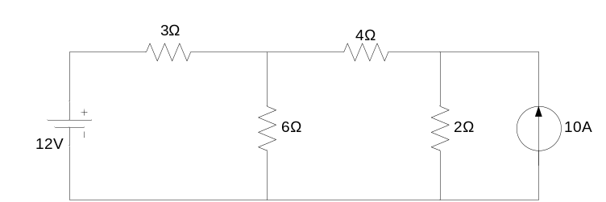

2 a) State and prove the maximum power transfer theorem and also show that maximum power transferred to the load is P_{Lmax}. = E²/4R_{L} ; where symbols have their usual meanings. [7]

b) Determine the current passing through 15Ω resistor connected across terminals in the circuit using Thevenin’s theorem. [8]
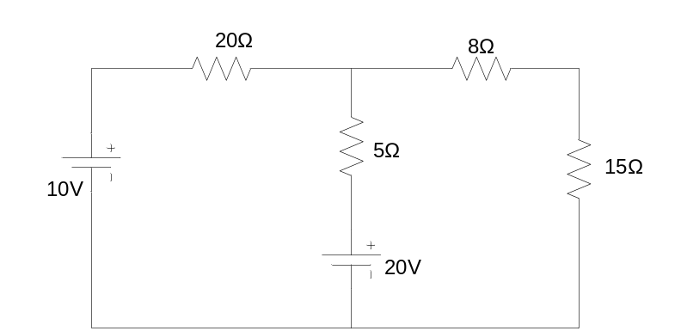

3 a) Define RMS value of alternating quantity. A coil of resistance 5Ω and inductance 0.12H in series with a capacitor of 100µF is connected across 250V, 50 Hz ac supply. Determine impedance, current, phase angle and power consumption. [2+6]
b) Find the average and root mean square value of the following waveform. [7]
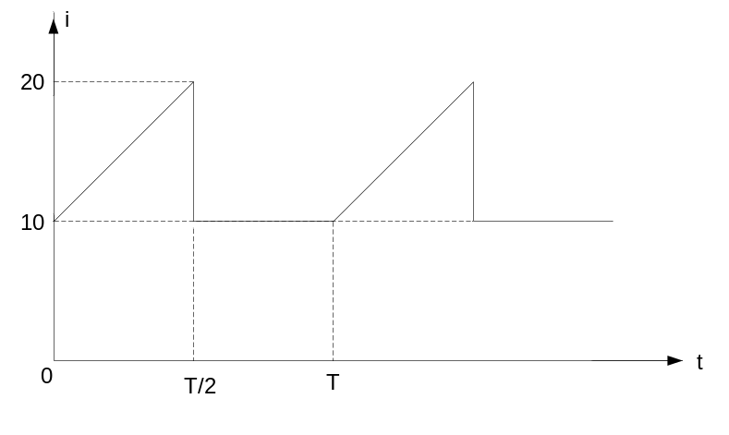
4 a) Explain the generation of a single phase alternating voltage. [7]
b) A 50 Ω resistor, 5mH inductor and 150µF capacitor are connected in series across 100V source. Find the resonant frequency, half power frequencies, bandwidth and current at resonance. [8]
5 Write short notes on any two of the following: [5*2]
a) Faraday’s laws of electromagnetic induction
b) Current Divider Rule
c) Powers in single phase ac.

